Power BI Euro Mart Report Creation Process

Power BI is one of the most widely used business intelligence tools in business and analytics platform in the market.

Power BI enables organizations to transform data into insights through data analysis and data visualization. One of the most common uses of Power BI in the business world is the creation of corporate dashboards and reports that allow business users to track their business performance, draw conclusions about their activity and, ultimately, make data-driven decisions.

In short, Power BI is the tool that allows us to convert data into understandable knowledge and ready to be analyzed by any type of user in a company, whether or not they have knowledge of data analytics or business intelligence. In this sense, Power BI promotes the democratization of information in the corporate environment.

Steps followed to create the Euro Mart Power BI report

1. Definition of needs and objectives:

The first step of any Power BI project is thinking about what we want to achieve. That is,analyzing our information needs and transforming them into business objectives and performance indicators that will structure our Power BI project.

2. Localization, preparation, definition and transformation of the data:

Power BI works by ingesting data. Data is the primary material the tool works with so its preparation is fundamental.

3. Turn data into knowledge:

Once the data is ready to be used, it can be transformed into information:

* **Contextualize them**: where they come from, when they were generated and why they are important.
* **Categorize them**: Define parameters and measures to classify and measure them.
* **Process and condense** them with aggregation guidelines.
* **Correct them**: eliminate inaccuracies, possible duplications, errors, etc.

Data has been modified, corrected and processed by combining multiple sheets with information spread across different files.

By using the Star Schema model the data has been integrated, modified and aligned as per the requirements to enhance the report and dashboard.

4. Utilizing the transformed data into a visually understandable report:

Creation of multiple visually explainable charts with information explaining how the company has been performing with sales, profit and several other factors contributing to the organisation’s performance.

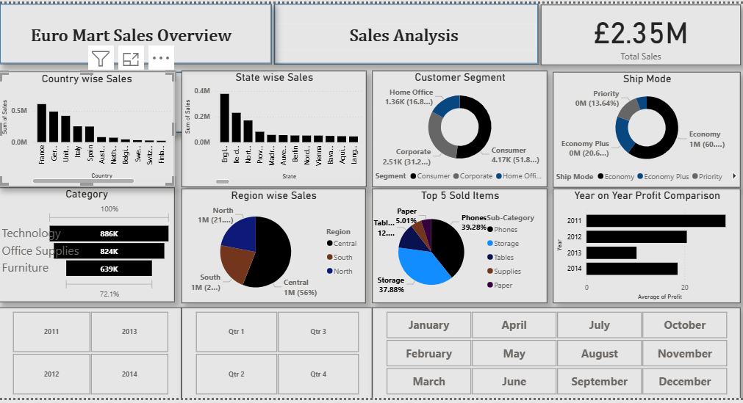

The Dashboard not only gives an insight into the breakup of understanding the company’s numbers it also allows us to understand which category or which item is performing well.

The report also includes multiple slicer filters which lets us review the numbers related to a specific month or a quarter or an overall year.

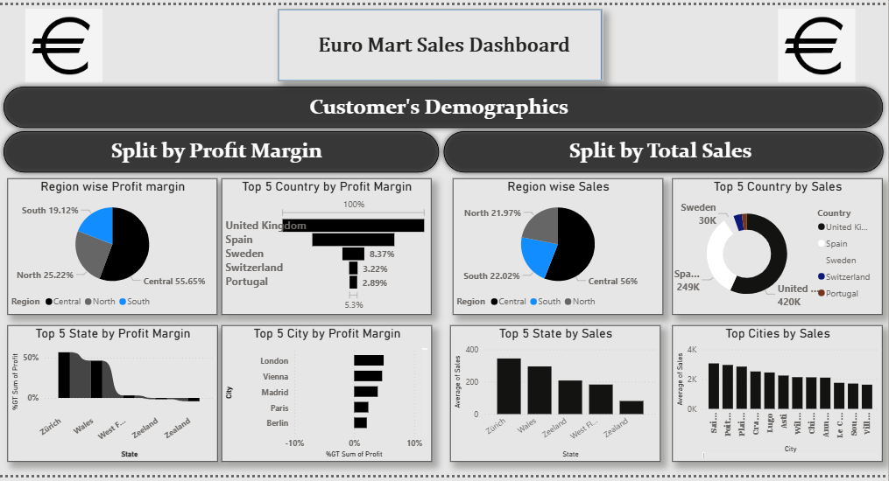

The second page in the Power BI report gives an insight into how the company has performed at different segments, region and margin related to sales and profit.

5. Conclusion:

The created report and dashboard can be used as a powerful visualisation tool to present, explain and share the data with the employees in the organisation for it to be utilized to enhance and improve the performance of certain aspects of the company.

Shortcut to the Euro Mart Presentation:



Vinay Raj R